**Break Down into Smaller Parts**

Once you have set clear boundaries round the problem and made the required assumptions, it’s time to break down the problem into smaller, more manageable parts.

This is the most critical part of solving a guesstimate question and it’s important that you ‘take a moment’ to think about how to go about it. Thirty seconds of silence now may save wasted time later in the interview. Remember that there are often multiple ways to break down a problem. You should pick the one which is logical and which you feel the most confident about.

You might find yourself thinking graphically at this point. Don’t hesitate to use a paper and pen to draw out your structure. If you do so, make sure that the interviewer is a part of it by showing what you are drawing/writing. Remember that guesstimate problems are back of the napkin calculations so they needn’t be unnecessarily long and subjective.

Breaking down the problem into smaller components helps you to focus on one small problem at a time which is easier to handle as compared to cracking the entire problem in one go. It also gives you the flexibility to revisit and correct a small part of your calculations if you think you have made a mistake rather than do all calculations again from scratch.

Here’s an example of how to break down a problem. Say, you are asked to:

*“Calculate the Total Sales of Lipsticks in the U.S.”*

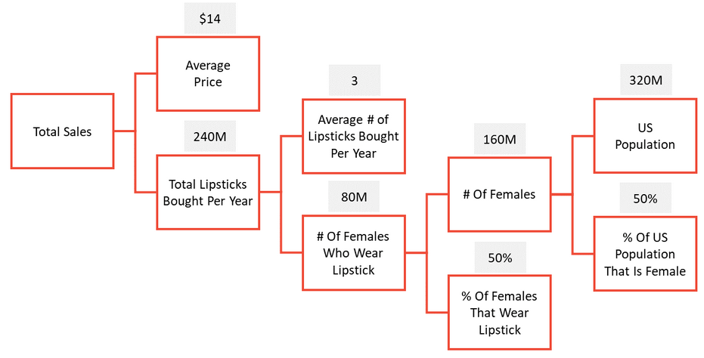

Mathematically speaking, *Total Sales = Average Price x Total Lipsticks Brought per Year.*

Further on, you can break down *Total Lipsticks Brought per Year* as: *Average # of Lipsticks Bought per Year* x *# of Females Who Wear Lipstick*.

It’s easy to calculate *# of Females Who Wear Lipstick* by multiplying: *# of Females in the U.S*. AND *% of Females That Wear Lipstick*

Once you have a logical structure in hand, all you have to do is feed in the numbers. Note that it is the approach that matters in the end. If it is logical and convincing, the interviewer will not worry too much about the figures that you put in.

For example, if you assumed that the population of U.S. is 320M when in fact it is 380M, it does not make a very big difference as long as your structure is sound.

Similarly, if you have assumed that 50% of the U.S population is female even when the accurate percentage might be different, you don’t have much to worry about. Just remember to focus on getting the logic right first.

Let’s look at another problem:

*“Calculate the number of Gas Stations in the U.S”*

**# Gas Stations in the U.S**

Demand fulfilled by 1 Gas Station

Total Daily Demand of Gas

**÷**

Daily Consumption per Vehicle

# Liters bought per Vehicle

# Vehicles served Daily

# Vehicles

**X X X**

# Vehicles per Pump (daily)

# Pumps

# Vehicles per Person

# People

**X X**

Remember the more problems you practice, the more intuitively you’ll be able to logically disintegrate them into smaller sub problems. So, keep practicing and perfecting your game!